**LIWC (Linguistic Inquiry and Word Count)**

**Temporal Data**

**present (present tense): Living in the here and now**

**Averages**

**Cuomo: 3.77**

Murphy: 2.68

Lamont: 2.53

De Blasio: 3.52

Trump: 3.25

**past (past tense): Focusing on the past**

**Averages**

Cuomo: 0.61

Murphy: 0.83

Lamont: 0.83

De Blasio: 0.78

**Trump: 1.20**

**future (future tense): Future and goal oriented**

**Averages**

**Cuomo: 0.82**

Murphy: 0.44

Lamont: 0.51

De Blasio: 0.43

Trump: 0.66

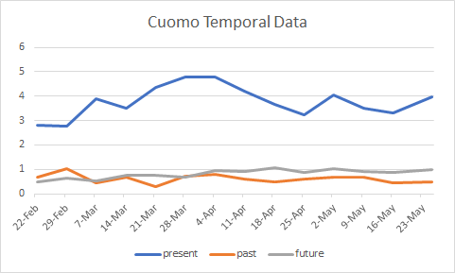

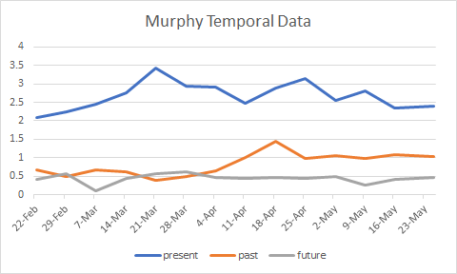

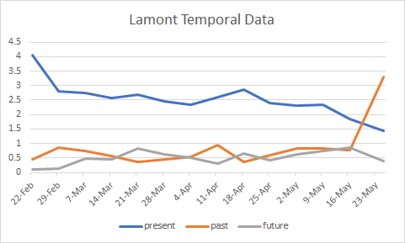

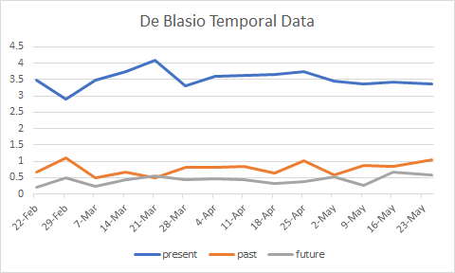

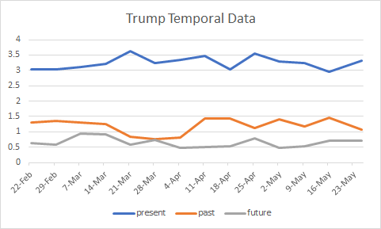

**Speaker Data**

**preps (prepositions): Education, concern with precision**

**Averages**

Cuomo: 6.64

Murphy: 7.25

**Lamont: 9.15**

De Blasio: 6.52

Trump: 6.54

**pronoun (total pronouns): informal, personal**

**Averages**

Cuomo: 3.32

Murphy: 3.72

Lamont: 2.98

**De Blasio: 3.89**

Trump: 3.70

**ppron (personal pronouns): personal, social**

**Averages**

Cuomo: 2.02

Murphy: 2.55

Lamont: 1.72

**De Blasio: 2.60**

Trump: 2.12

**social (social processes): social concerns, social support**

**Averages**

Cuomo: 3.69

Murphy: 4.41

Lamont: 4.06

**De Blasio: 4.58**

Trump: 3.77

**affect (affective processes): Emotionality**

**Averages**

Cuomo: 2.23

Murphy: 2.40

Lamont: 1.78

De Blasio: 2.06

**Trump: 2.71**

**excl (exclusive): Cognitive Complexity, Honesty**

**Averages**

Cuomo: 0.47

Murphy: 0.49

Lamont: 0.27

**De Blasio: 0.61**

Trump: 0.57

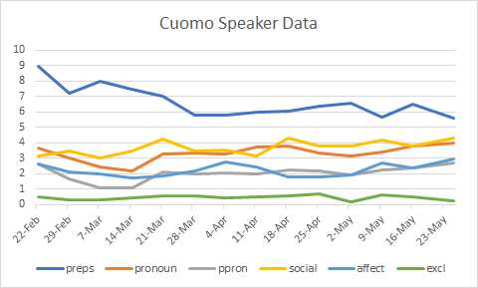

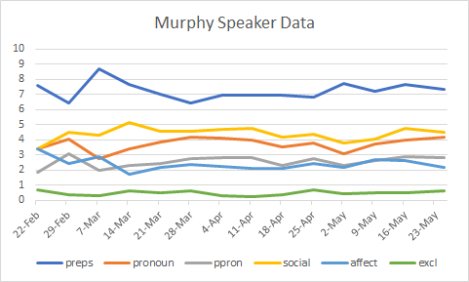

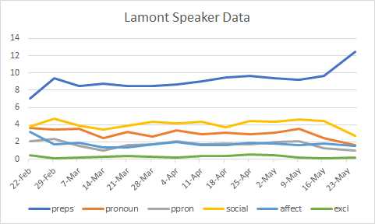

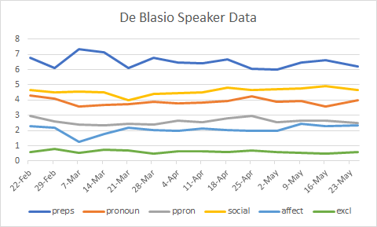

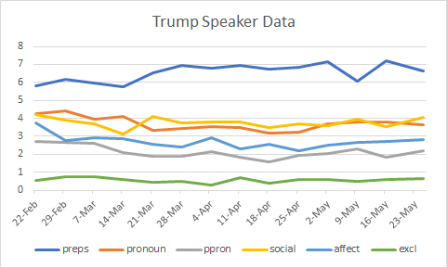

**Emotional Data**

**posemo (positive emotions)**

**Averages**

Cuomo: 1.41

Murphy: 1.62

Lamont: 1.45

De Blasio: 1.32

**Trump: 1.70**

**negemo (negative emotions)**

**Averages**

Cuomo: 0.81

Murphy: 0.76

Lamont: 0.30

De Blasio: 0.73

**Trump: 1.00**

**anger (anger)**

**Averages**

Cuomo: 0.25

Murphy: 0.22

Lamont: 0.08

De Blasio: 0.25

**Trump: 0.39**

**anx (anxiety)**

**Averages**

**Cuomo: 0.18**

Murphy: 0.11

Lamont: 0.05

De Blasio: 0.14

Trump: 0.12

**sad (sadness)**

**Averages**

Cuomo: 0.23

**Murphy: 0.27**

Lamont: 0.06

De Blasio: 0.18

Trump: 0.17

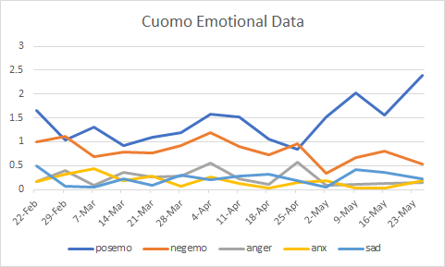

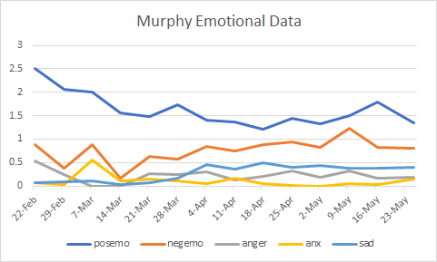

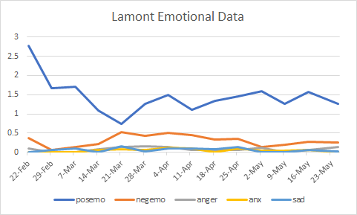

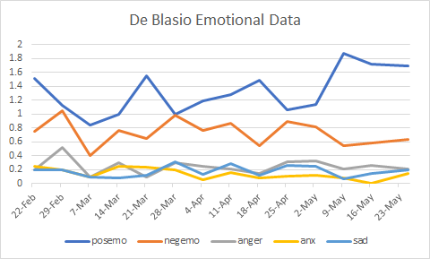

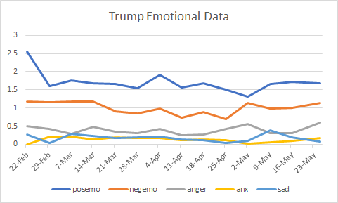

**Reasoning Data**

**negate (negations): Inhibition**

**Averages**

Cuomo: 0.28

Murphy: 0.23

Lamont: 0.13

De Blasio: 0.23

**Trump: 0.32**

**insight (insight): think, know, consider**

**Averages**

**Cuomo: 0.70**

Murphy: 0.62

Lamont: 0.11

De Blasio: 0.60

Trump: 0.56

**cause (causation): because, effect, hence**

**Averages**

**Cuomo: 0.71**

Murphy: 0.62

Lamont: 0.61

De Blasio: 0.55

Trump: 0.58

**discrep (discrepancy): should, would, could**

**Averages**

Cuomo: 0.55

Murphy: 0.31

Lamont: 0.31

**De Blasio: 0.62**

Trump: 0.58

**tentat (tentative): maybe, perhaps, guess**

**Averages**

Cuomo: 0.43

Murphy: 0.40

Lamont: 0.34

**De Blasio: 0.63**

Trump: 0.55

**certain (certainty): Social/verbal skills, emotional stability**

**Averages**

Cuomo: 0.81

**Murphy: 0.91**

Lamont: 0.74

De Blasio: 0.59

Trump: 0.81

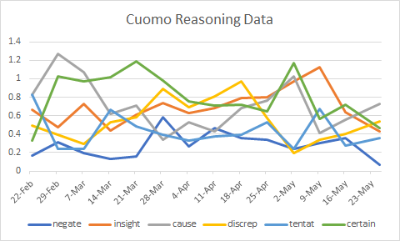

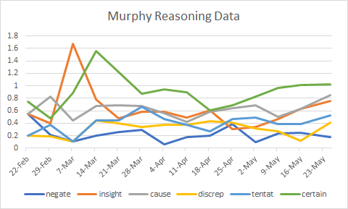

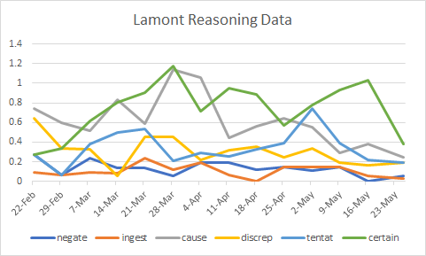

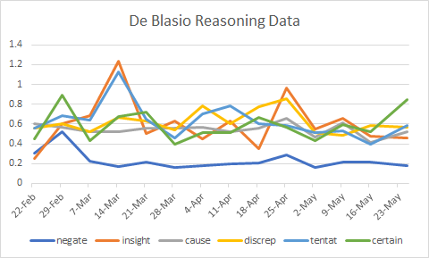

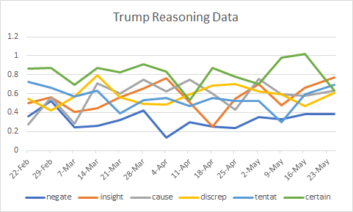

**Perceptive, Biological, Relativity Data**

**percept (perceptual processes): observing, hearing, feeling**

**Averages**

Cuomo: 0.36

Murphy: 0.35

Lamont: 0.36

De Blasio: 0.50

**Trump: 0.58**

**bio (biological processes): eat, blood, pain**

**Averages**

**Cuomo: 1.01**

Murphy: 0.90

Lamont: 0.68

**De Blasio: 1.01**

Trump: 0.44

**relativ (relativity): motion, space, time**

**Averages**

Cuomo: 6.63

Murphy: 7.05

**Lamont: 8.91**

De Blasio: 6.54

Trump: 5.74

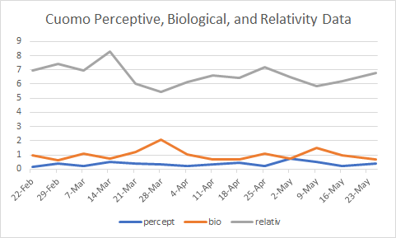

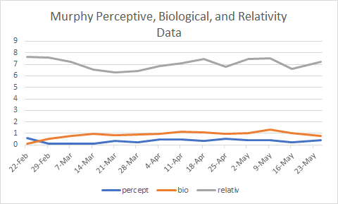

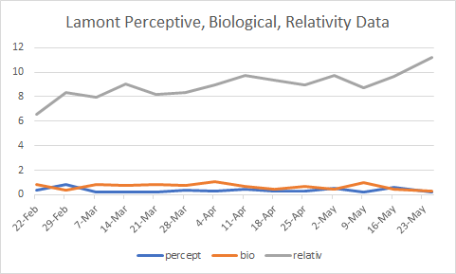

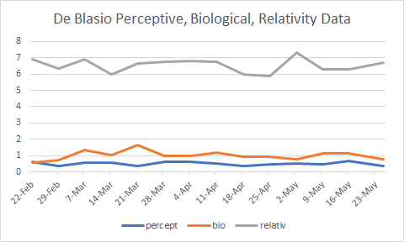

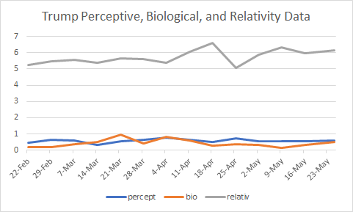

**Tangibles Data**

**work (work): jobs, majors**

**Averages**

Cuomo: 1.55

Murphy: 1.84

**Lamont: 2.16**

De Blasio: 1.26

Trump: 1.33

**achieve (achievement): earn, win, hero**

**Averages**

Cuomo: 1.23

**Murphy: 1.30**

Lamont: 1.05

De Blasio: 1.12

Trump: 1.10

**leisure (leisure): cook, chat, movie**

**Averages**

Cuomo: 0.33

Murphy: 0.38

**Lamont: 0.47**

De Blasio: 0.34

Trump: 0.31

**home (home): apartment, kitchen, family**

**Averages**

Cuomo: 0.27

**Murphy: 0.40**

Lamont: 0.31

De Blasio: 0.27

Trump: 0.09

**money (money): audit, cash, owe**

**Averages**

Cuomo: 0.37

**Murphy: 0.68**

Lamont: 0.41

De Blasio: 0.30

Trump: 0.53

**relig (religion): altar, church, mosque**

**Averages**

Cuomo: 0.05

**Murphy: 0.09**

Lamont: 0.03

De Blasio: 0.06

Trump: 0.05

**death (death): bury, coffin, kill**

**Averages**

Cuomo: 0.09

Murphy: 0.08

**Lamont: 0.25**

De Blasio: 0.06

Trump: 0.09

**family (family): daughter, husband, mother**

**Averages**

Cuomo: 0.12

**Murphy: 0.19**

Lamont: 0.08

De Blasio: 0.12

Trump: 0.05

**friend (friends): buddy, friend, neighbor**

**Averages**

Cuomo: 0.08

**Murphy: 0.09**

Lamont: 0.05

**De Blasio: 0.09**

**Trump: 0.09**

**humans (humans): adult, baby, boy**

**Averages**

Cuomo: 0.34

Murphy: 0.38

**Lamont: 0.47**

De Blasio: 0.32

Trump: 0.30

**health (health): medicine, hospital, sick**

**Averages**

**Cuomo: 0.71**

Murphy: 0.69

Lamont: 0.48

De Blasio: 0.65

Trump: 0.29

